Experiment No. 2
Ridge Regression and Lasso Regression
Name : Rishabh Ramani
Class : D15B
Roll No : 48
Batch : B

Aim
To implement and compare Ridge Regression (L2 regularization) and Lasso Regression (L1 regularization) on a real-world dataset.

1. Dataset Source
Dataset Name: Heart Disease / Medical Dataset

2. Dataset Description
The target variable indicates whether a patient has heart disease:
- Target = 1 → Presence of heart disease
- Target = 0 → Absence of heart disease
The dataset consists of both numerical and categorical features, making it suitable for regression with regularization techniques.

3. Mathematical Formulation

Ridge Regression (L2 Regularization)
J(β) = Σ(yᵢ - ŷᵢ)² + λ Σβⱼ²

Lasso Regression (L1 Regularization)
J(β) = Σ(yᵢ - ŷᵢ)² + λ Σ|βⱼ|

Mathematical Formulas:
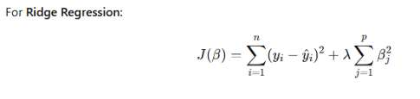
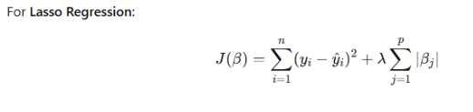

4. Algorithm Limitations
- Ridge does not perform feature selection (only shrinks coefficients)
- Lasso can be unstable with highly correlated features
- Choosing optimal λ requires cross-validation
- Both assume linear relationship between features and target

5. Methodology / Workflow
- Load dataset
- Handle missing values
- Encode categorical features
- Feature scaling (StandardScaler)
- Train-test split
- Train Linear, Ridge, and Lasso regression models
- Evaluate and compare performance

6. Performance Analysis
Evaluation Metrics Used:
- R-squared (R²)
- Mean Absolute Error (MAE)
- Root Mean Squared Error (RMSE)

Output / Results:
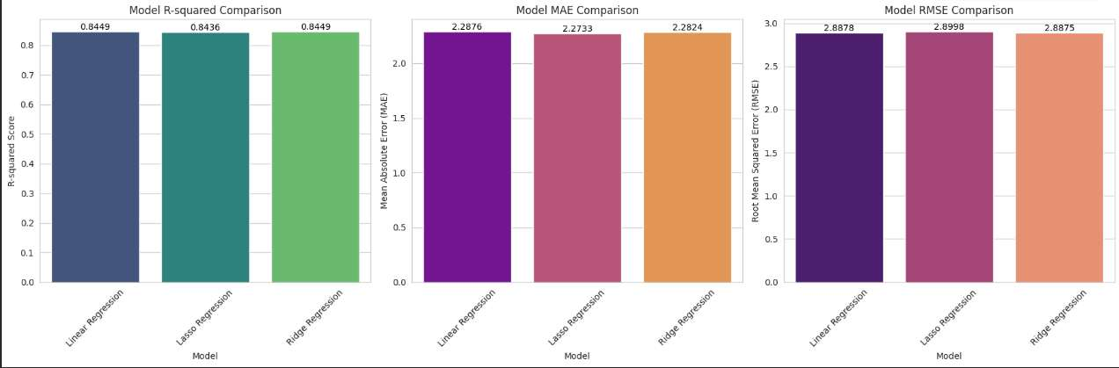

Linear Regression: R² = 0.8449, MAE = 2.2876, RMSE = 2.8878
Lasso Regression: R² = 0.8436, MAE = 2.2733, RMSE = 2.8998
Ridge Regression: R² = 0.8449, MAE = 2.2824, RMSE = 2.8875

7. Hyperparameter Tuning
Parameter Tuned: Regularization strength (α / lambda)
Method: GridSearchCV with cross-validation

Impact:
- Reduced overfitting
- Improved generalization on test data
- Lasso performed feature selection by driving some coefficients to zero

Conclusion
Ridge and Lasso regression are powerful regularization techniques that improve upon basic Linear Regression. Ridge is preferred when all features are relevant, while Lasso is useful for feature selection. Both achieved similar R² scores (~0.84) on the dataset, confirming strong model fit.

